FCE Writing Quiz

- How many pieces of writing must a candidate complete in the exam?

- What are the different text types that candidates may write?

- How many words long (from x - y words) must each piece be?

- How many Criteria are used to mark a piece of writing?

*For bonus points, what are they called?*

- Which are the most important difficult criteria for candidates to score well on?

from: Assessing writing for Cambridge English Qualifications: A guide for teachers (Cambridge English).

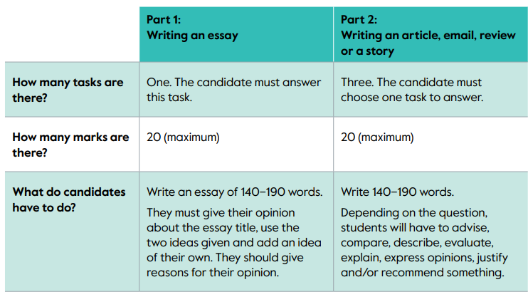

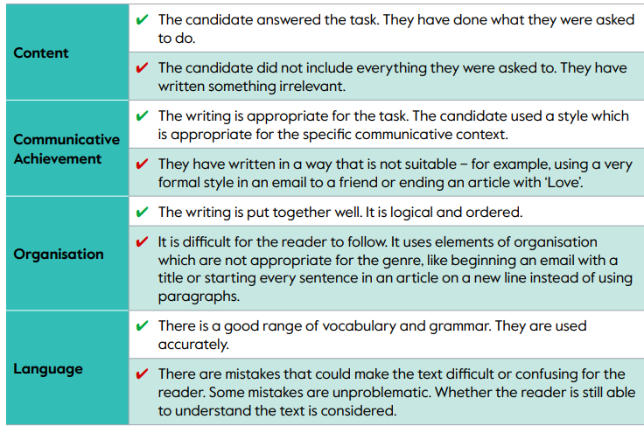

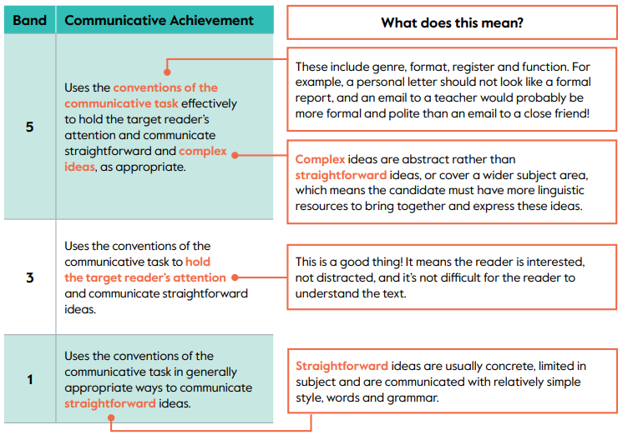

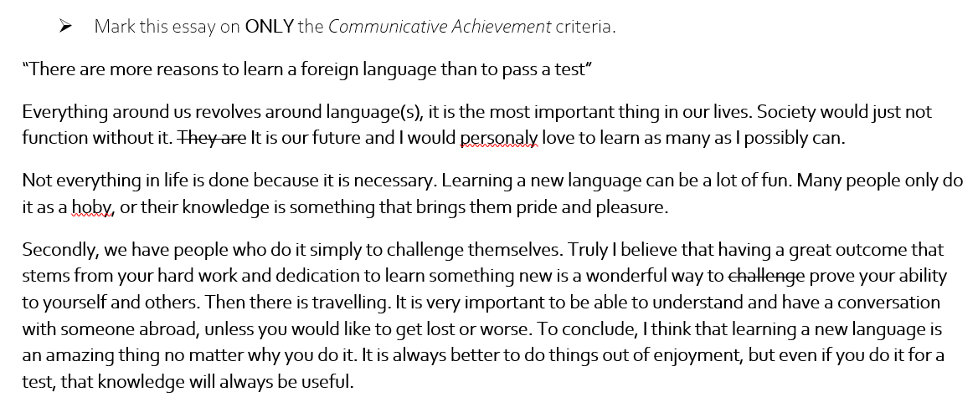
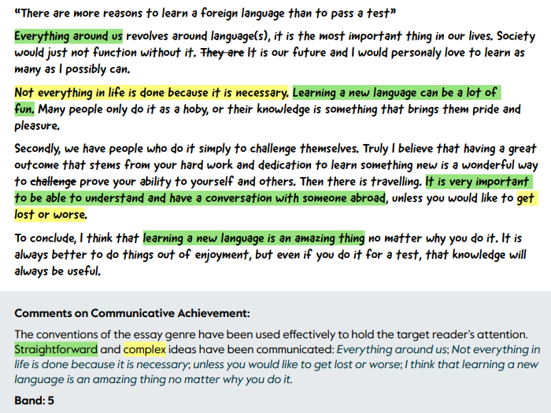
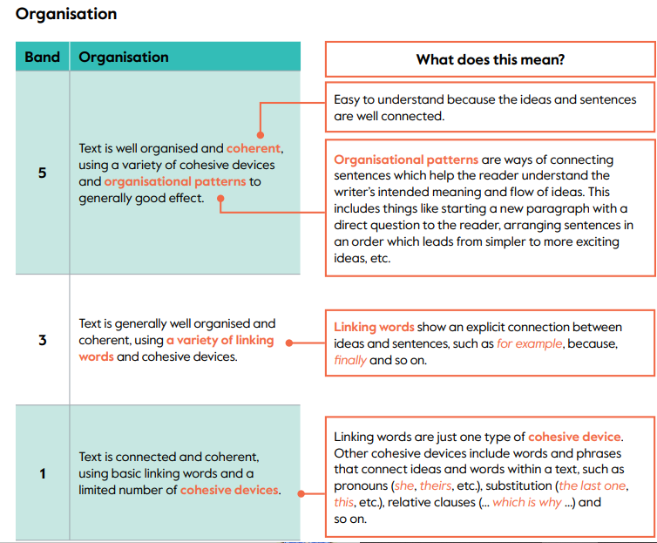

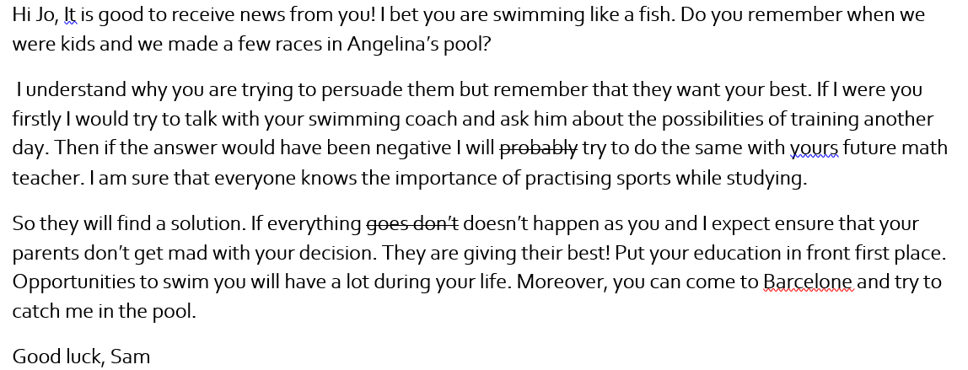

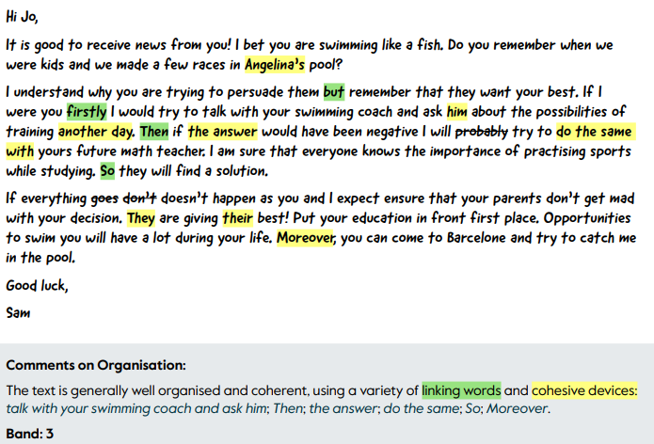

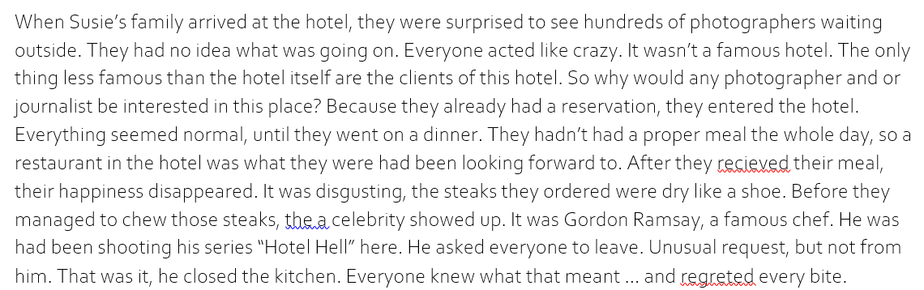
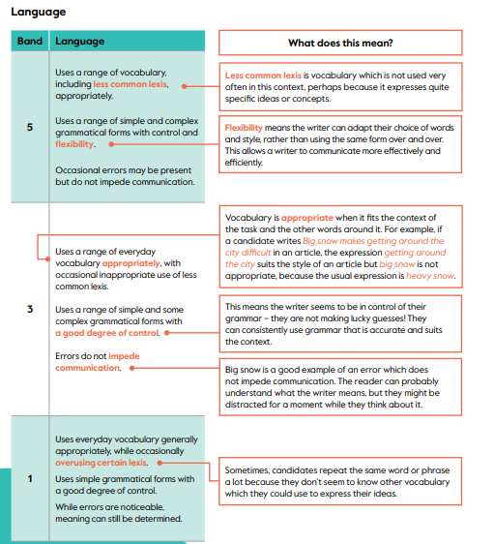
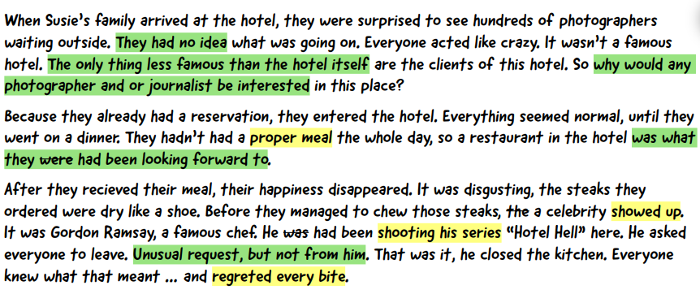

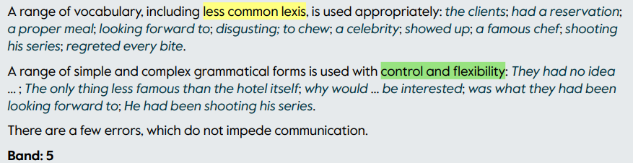

In your English class you have been talking about the environment. Write an essay using the notes and give reasons for your point of view.
Every country in the world has problems with pollution and damage to the environment.
Do you think these problems can be solved?

Write about:

1. transport
2. rivers and seas
3. ………………………… (your own idea)

Well, I think that my country has problems with pollution to environment like all other countries. This problem is normal for Malaysia. We have big problems with transport because there are too much cars in our country. And because of that we have problems with atmospeer, air in my city and in all Malaysia is really dirty and sometimes I can’t make a sigh because it smells around me and of course around that cars on the road. I’ve heard about tradition of one country. They don’t go anywhere by car one day a month or a year, they just use bycicle or their feet. I think it could be very good if we had a tradition like that.
So, what about the rivers and the seas? Yeah, there are some really good and clean rivers and seas where you can go, but there are not many of them. Once I saw the river in my city, it was about two years ago but I stil remember that in some places it was not blue, it was green or purple I didn’t really understand because it had different colours.
I dunno what should we do. Maybe we should just open our eyes and look what we did. But Malaysian people don’t care about the world around them many people care only about themselves an that’s all.
So, the best idea is look around and try to do something good for our planet and for us and for children.

