Cambridge Delta Modules Application

Personal and contact details
Name:
Course applied for: full-time/part-time* Module 1 course*
Module 2 course*
Module 1 and 2 courses together*
Course starting on:
Date of birth: | Nationality:
Email:
Contact address: |  | Phone:
Permanent address (if different): |  | Phone:
Would you like us to help you arrange accommodation? yes/no
Do you need a visa to come to the Czech Republic? yes/no
* delete as appropriate
Non-TEFL Qualifications please list only the institutions attended and qualifications gained after secondary education
Qualification | Institution | Dates

TEFL Qualifications
Qualification | Institution | Dates

TEFL Experience - please include present position and give more information on types of classes (levels, L1, number of students, coursebooks). Add/expand rows if you need more space.
Institution | Position (full/part time) | Dates

Non-TEFL Teaching Experience – if any
Institution | Position | Dates

Languages spoken
Language | Level of proficiency

General Health (please mention any medical problem that may affect your performance on the course or that can be exacerbated by higher level of stress or disrupted daily routines, or that would require special arrangements)
Total amount of full-time TEFL Experience: Years: _______ Months: ______
I confirm that all the information I have given above is correct.
Signature/Name: ________________________ Date: _____________

Now please complete the application tasks below according to the course you are applying for (not all of them are required if applying for the Delta Module 1 course only). Then, save the application as a Word document (.doc or .docx) and send it to Marki Čalkovská (marketa.calkovska@akcent.cz).
Cambridge Delta Modules Application Tasks

Your application cannot be considered without these tasks.
Name:

Task 1 – for all applications
Say briefly how you feel you would benefit from taking the Delta Modules course.
Your answer (up to 200 words):

Task 2 – for all applications
Below there is an authentic news article, read it and do the related tasks below.
Iceberg the size of Greater London is about to split off Antarctica, NASA warns
Rob Waugh Monday 25 February 2019
An iceberg the size of Greater London could soon be unleashed, as cracks are spreading across Antarctica’s Brunt Ice Shelf, NASA has warned.
Images from NASA’s Landsat satellites show a huge crack which is spreading northward at a rate of around 2.5 miles per year – and could put the whole Brunt ice shelf at risk.
NASA says that the ice shelf itself may become unstable and collapse – and says that the ‘calving’ is the biggest since observations of the ice shelf began in 1915.
When the crack goes all the way across the ice shelf, the area lost will be at least 660 square miles – the size of Greater London
Scientists are watching to see if the loss will trigger the shelf to further change and possibly become unstable or break up.
The growing cracks have prompted safety concerns for people working on the shelf, particularly researchers at the British Antarctic Survey’s Halley Station. This major base for Earth, atmospheric, and space science research typically operates year-round, but has been closed down twice in recent years due to unpredictable changes in the ice.
Joe MacGregor, a glaciologist at NASA’s Goddard Space Flight Center said, ‘The near-term future of Brunt Ice Shelf likely depends on where the existing rifts merge relative to the McDonald Ice Rumples.
‘If they merge upstream (south) of the McDonald Ice Rumples, then it’s possible that the ice shelf will be destabilized.’
Calving is a normal part of the life cycle of ice shelves, but the recent changes are unfamiliar in this area.
The edge of the Brunt Ice Shelf has evolved slowly since Ernest Shackleton surveyed the coast in 1915, but it has been speeding up in the past several years.
From www.metro.co.uk

- This text is a news article, identify 3 features of this text which are typical of news articles as a genre.

- Here are phrases from the text containing articles. Describe the meaning/use and form of the articles.
  - An iceberg…
    - Meaning/use:
    - Form:
  - Ø Scientists are watching…
    - Meaning/use:
    - Form:
  - … but the recent changes…
    - Meaning/use:
    - Form:

- In these phrases from the text, describe the meaning/use and form of the grammatical structures in bold:
  - Nasa has warned
    - Meaning/use:
    - Form:
  - which is spreading northward
    - Meaning/use:
    - Form:
  - Scientists are watching to see if the loss will trigger the shelf to further change
    - Meaning/use:
    - Form:

- Identify at least 3 pronunciation features that could cause difficulties for learners in the following extract, assuming usual spoken pronunciation.
Calving is a normal part of the life cycle

Task 3 – for all applications
Here is an extract from “Teaching Grammar: From Rules to Reasons” by Danny Norrington Davies:
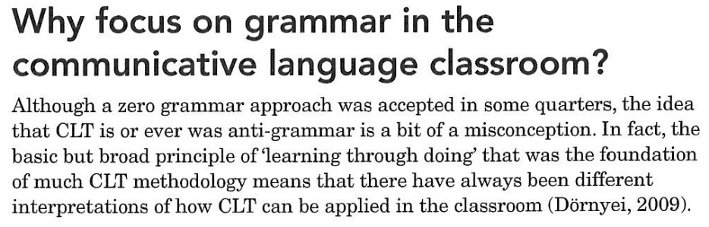
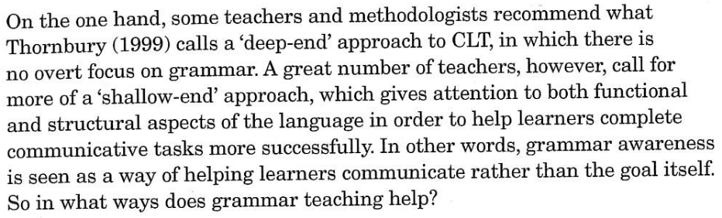
From: “Teaching Grammar: From Rules to Reasons”, Norrington-Davies D., Pavilion Publishing, 2016.

- Identify and explain 4 benefits of having an explicit grammar focus in English lessons.

- What reasons could be given for the ‘zero grammar approach’ mentioned about, try to give 3 or 4.

Task 4 – for applications for Module 2
Choose one of these four topics and explain your opinion about them, including examples from your own teaching and/or references to EFL reading you have done.
a) Use of mother tongue in class
b) Clarifying and practising grammar
c) Helping learners read better
d) Correcting learners’ errors
Your answer (400-600 words):

Task 5 – for applications for Module 2
Please attach a lesson plan for a successful lesson that you have taught recently, preferably with some skills and systems focus. The plans should contain:
-lesson aims
-level and type of class (YLs, business English, ESP, exams etc.)
-length of the lesson
-brief description of lesson procedure with stage aims, timing and interaction
-a brief (up to 150 words) post-lesson self-evaluation of how the lesson went
-materials used in the lesson (scanned coursebook page, hand-outs or tape-script – no need to send all pictures or the audio)
You should be ready to discuss these lessons during the interview.

The Interview
If your application is successful, you will be invited for a Skype, phone or face-to-face interview. The interview is not meant to be unpleasant or difficult. It is a Cambridge ESOL regulation and its main purpose is to check that you have the potential to do well on the course before you invest the time, effort and money, and to inform you about the course organisation.
Preparation for the interview:
a) You should read about DELTA Modules content, syllabus and assessment requirements in the DELTA Modules Handbook downloadable from http://www.cambridgeenglish.org/images/181161-delta-handbook-for-tutors-and-candidates-document.pdf
to familiarise yourself with the content of Delta Module 1 and/or 2 as relevant and how they are assessed.
b) Before the interview, the interviewer will send you a scanned page from a coursebook to look at, and a brief task. You might like to take notes about your answers but there is no need to submit a lesson plan.

What you have written will be used for discussion at interview –
so please keep a copy for yourself.

